Lin 177 Final Project

Nicholas Phomsopha

7/27/19

The Syllable Structure Of Thai

For my final project of Lin 177 I decided to model the syllable structure of Thai. That Thai is considered to be an orthographic syllable meaning it can have a simple structure of a Initial Consonant, vowel , and an optional final consonant. However certain initial consonants can begin in what is a consonant cluster, which can give it multiple phonetic syllables. That what made me interested in modeling Thai syllables the most, it can be simple looking at it, but diving deeper it became more complex with the use of long, short vowels, tonal changes like rising and falling which changes the whole meaning depending on what you use.

Main Component of Thai Syllable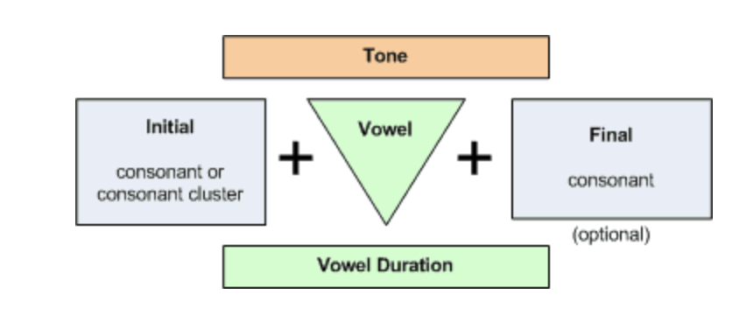

The main reasons I chose to model Thai because its similar to the language my family speaks at home. That coming from a Laotian background the Thai language is very similar in point that its mutually exclusive to Laos language, in turn that you can speak with people in Thailand and Laos alike. This project gives me a huge opportunity to learn about the language I’m not really familiar with that is apart of my culture. From this final project it gave me a huge insight on how different syllables are from different languages and how their structure varies.

In my project I’m focusing on the sounds of the three categories of Thai, Initial Consonant, Vowel, And Final Consonant. I feel I couldn’t efficiently capture the tone and vowel duration in prolog, so I did not include that in my project. In Thai initial consonants they are split into 3 main components, Plain, Sonorant, and aspirate.

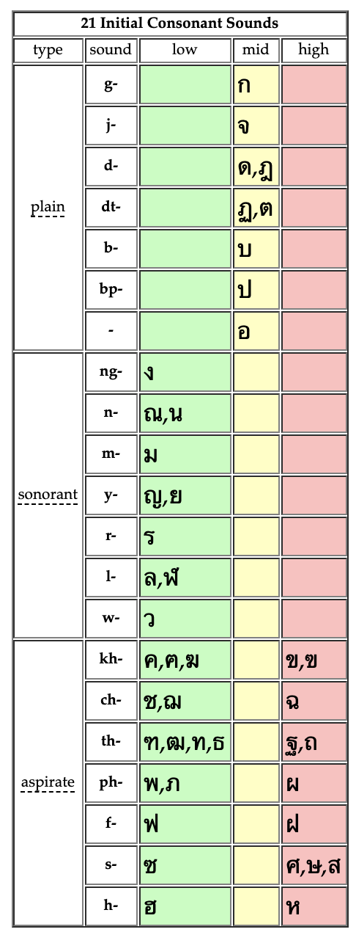

Converting Thai Alphabets to ipa

Plain IPA – p,k,t,b,j,

Sonorant IPA – [ŋ](https://en.wikipedia.org/wiki/Velar_nasal), n ,m j,r,l,w

Aspirate IPAs – x,s, th, ph, f ,h

Along with the type of consonant sounds, the initial consonant of a Thai Syllable can be started with a consonant cluster, which is two consonants put together to form a beginning sound. There are two models I included in my project, True consonant clusters, and false consonant clusters. A true Cluster can start with k,x,t,p,ph and end with r,l,w. false clusters can start with tg,s,th,r and end with r which is silent. Consonant clusters can only start in the initial consonant, not final consonant.

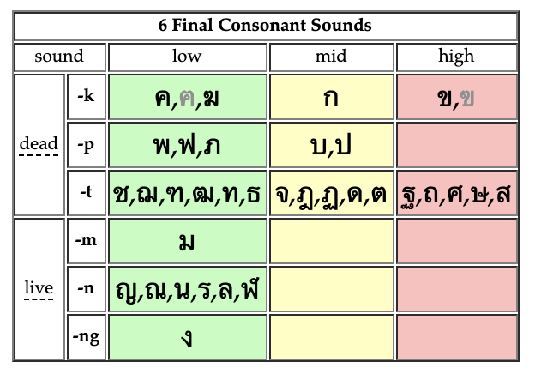

The final consonant is optional in a Thai Syllable, it can have these sounds ending that make it a live or dead syllable. From the syllables you can see what tone it can have. Live syllables tend to have long vowel durations and mid tone while dead syllables have short vowel durations and low tones.

The main sources I used that applied to our class was the English syllable program, I was able to use most of while adding some phones that were present in Thai, but not English. The main different of Thai is that it does not use onsets or rhymes to make a syllable, Thai can have as little as an Initial consonant and a vowel to make a valid syllable. You can query my Thai prolog program the same as English with “syllable(X).” to get all valid syllables in Thai

Some challenges during implementation of my Thai syllable generator was that some Thai characters shared multiple IPA’s with each other which made following Thai syllable rules tricky. For example, IPA S has 7 Thai symbols/ alphabet lettering that share that particular IPA. Also, the task of converting Thai alphabet letters to IPA was tricky since I had to manually convert each alphabet to IPA for each rule in the Thai syllable. One main issue I wanted to solve is the vowel duration as well as tone for the Thai syllable. That both the tone and vowel duration helps gives Thai syllables different meanings while using the same phonetic structure. That I felt like I could not portray this in prolog accurately I left it out. I felt like it was on the edge of my project scope, that I just wanted to generate the basic structure of a Thai syllable, not make a word generator for Thai, which I think the vowel duration and tonal changes are. This leads to one of the last consonant clusters I did not model, which was leading consonant clusters that change the tone and vowel duration. I did not model this for the same reasons as the vowel and tone properties.

Overall I believe that my project was constructed in a principled manner. I defined all my phones that I used to create my syllables with natural classes. My predicates used variables and I defined the variables with natural classes, not using an ad-hoc approach. That I mainly used phonetic properties to define my predicates which was one of the principle topics we have learned in class.

Main Sources

<http://www.thai-language.com/ref/consonants#isounds>

For diagrams used here and help with syllable structure

<https://en.wikipedia.org/wiki/Help:IPA/Northern_Thai>

for helping to convert Thai alphabet letters to IPA to make Thai syllable IPA compatible.